1. **INTRODUCTION**

**A travel agency is a private retailer or public service that provides travel and tourism-related services to the general public on behalf of accommodation or travel suppliers to offer different kinds of travelling packages for each destination. Travel agencies can provide outdoor recreation, arranging logistics for luggage and medical items delivery for travellers upon request, public transport timetables, car rentals, and bureau de change services. Travel agencies can also serve as general sales agents for airlines that do not have offices in a specific region. A travel agency’s main function is to act as an agent, selling travel products and services on behalf of a supplier. They are also called Travel Advisors. They do not keep inventory in-hand unless they have pre-booked hotel rooms or cabins on a cruise ship for a group travel event such as a wedding, honeymoon, or other group event.**

1. **PURPOSE**

**A travel agency is a company that books and organises trips for customers on behalf of suppliers. They can offer a range of services from finding the best flights and accommodation deals to creating a travel itinerary and keeping you informed about any medical or visa requirements.**

**They can also offer flexible payment options and can help you get a passport that is valid for your travel date. This can be particularly helpful for people who are planning an international trip.**

**Travel agents can work in a variety of positions, including retail, wholesale and independent. A retail travel agent works with clients face-to-face, helping them to plan their holidays. A wholesale travel agent carries out the same task, but works with a network of other agents. These travel agencies are able to get better deals from suppliers as they can book their clients’ flights, hotels and tours in bulk.**

**The travel industry is a lucrative one for those with the right skills, and there are many openings for travel agents across the country. Most agents start as junior counter staff, moving into management jobs after a few years. The job duties and pay of a travel agent vary by state and region.**

**Some travel agencies are located in brick-and-mortar buildings, but most operate online. They use their website to connect travelers with travel suppliers, allowing them to research, plan and book trips.**

**They may also provide information on local tourist attractions, events and customs. They can provide a list of recommended hotels, restaurants and other places to stay.**

**These agencies can also give advice on the cost of travel, including tips for budgetconscious vacationers. They can also offer travel insurance and a host of other services that can make a trip easier.**

**You can become a travel agent with a high school diploma, although some college training is also helpful. A degree in business, tourism, marketing or international affairs can help you develop your travel expertise and build your client base.**

**A good knowledge of the tourism industry, including how to book flights, hotels and tours, is essential for a travel agent. In addition to this, you should have strong interpersonal and communication skills. These skills will help you work effectively with your clients and other travel agencies.**

**Some travel agencies provide a wide range of services to their clients, and others specialize in certain niches, such as cruises or adventure travel. These agencies typically provide a higher commission for their clients than traditional travel agents.**

**Niche travel agencies are becoming more popular with travelers. These are typically independent travel agencies that focus on specific categories, such as ecotourism, agritourism, cultural tourism, health and wellness and cruise travel.**

**PROBLEM DEFINITION & DESIGN THINKING**

**2.1 EMPATHY MAP**

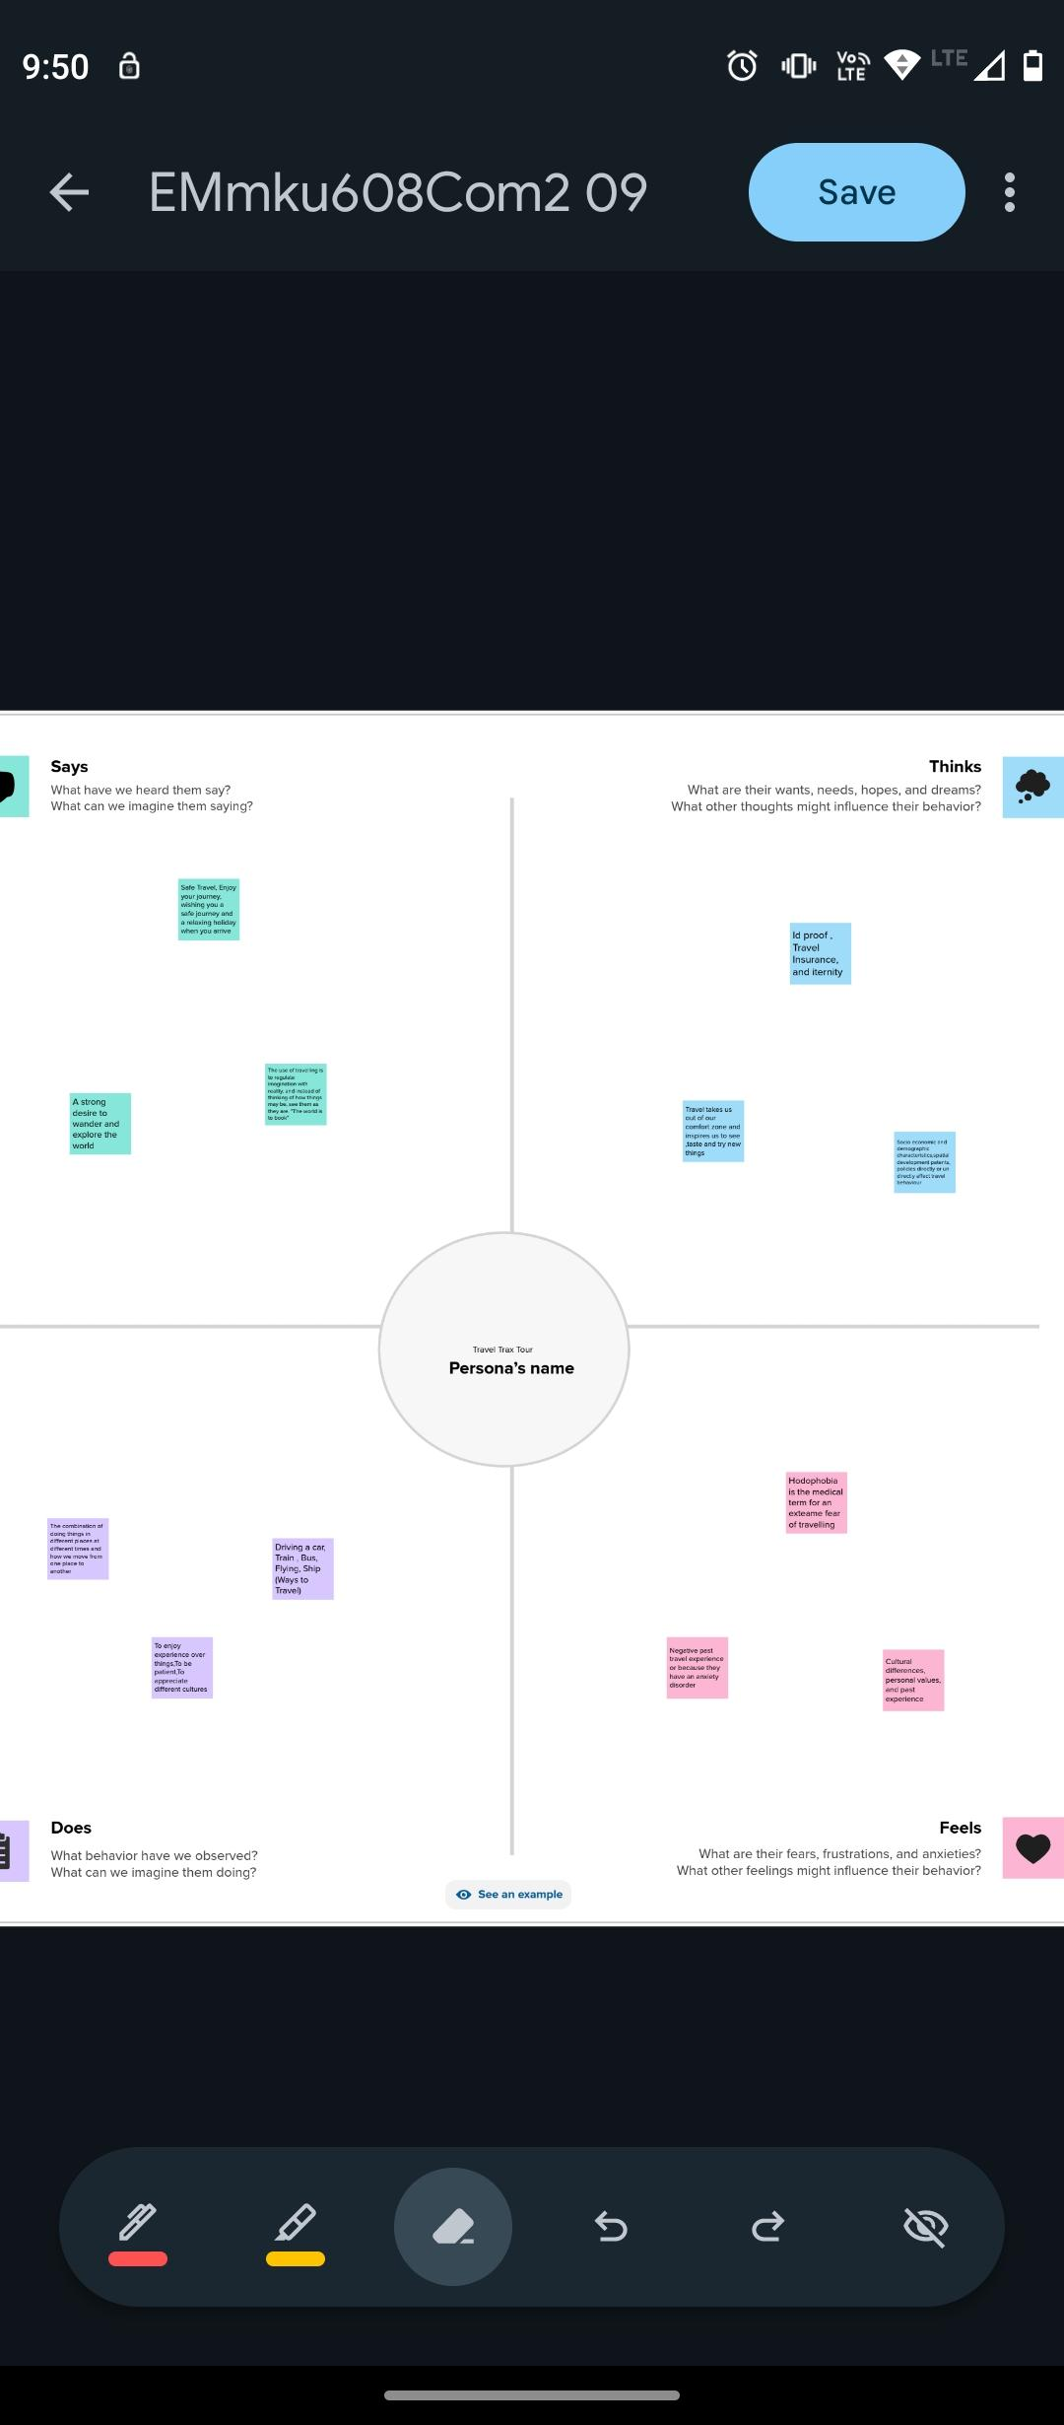

**2.2. IDEATION & BRAINSTORMING MAP**





1. **RESULT**

**FINAL FINDING (OUTPUT) OF THE PROJECT ALONG WITH SCREEN SHOT**

**GST REPORTS:**

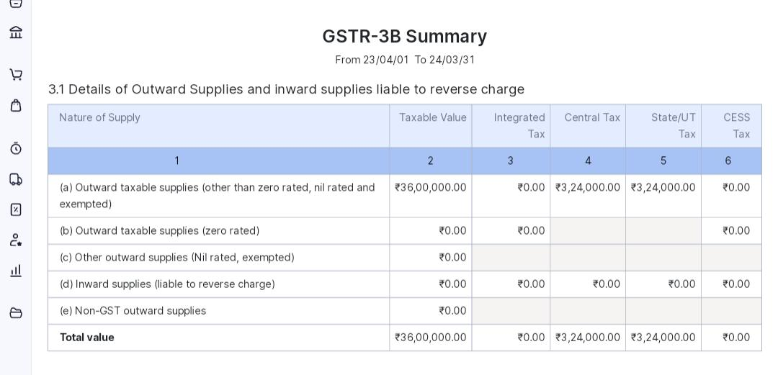

**SALE INVOICE:**

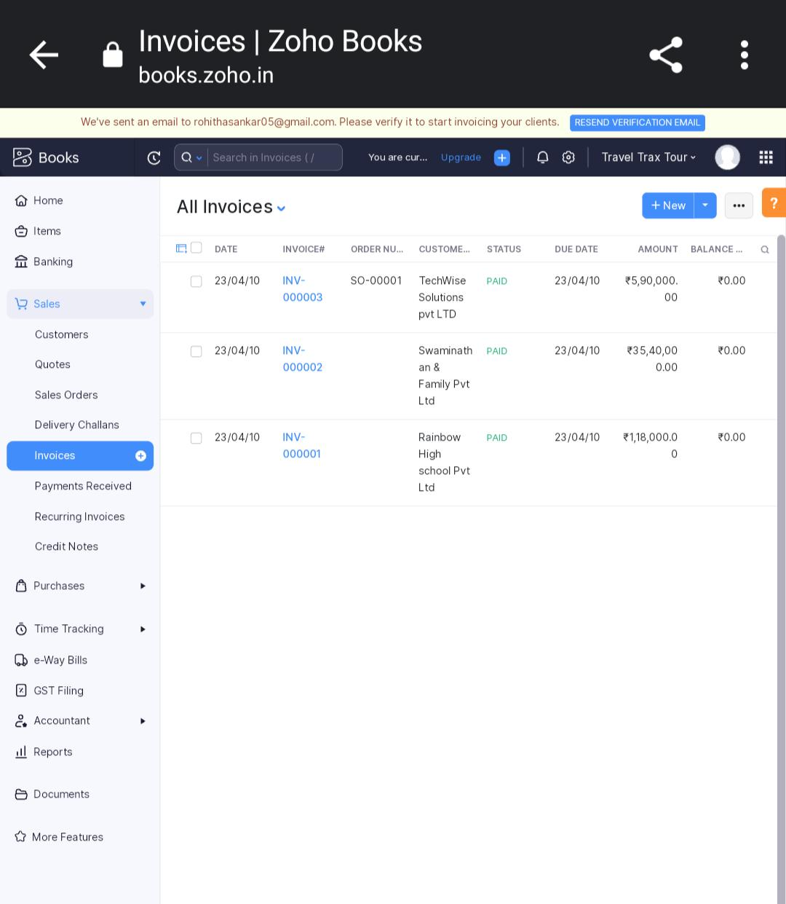

**PURCHASE BILLS:**

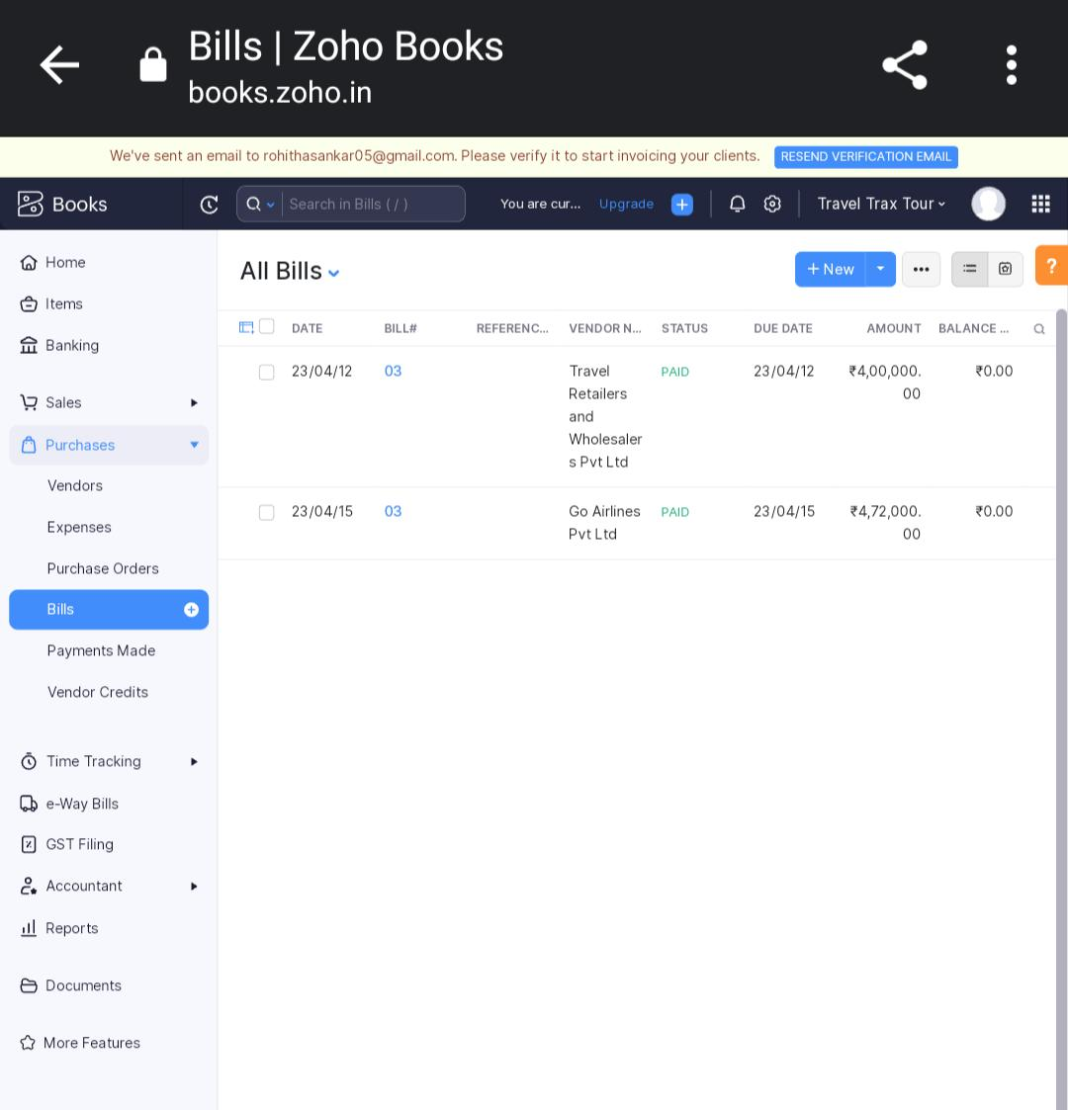

**VENDORS :**

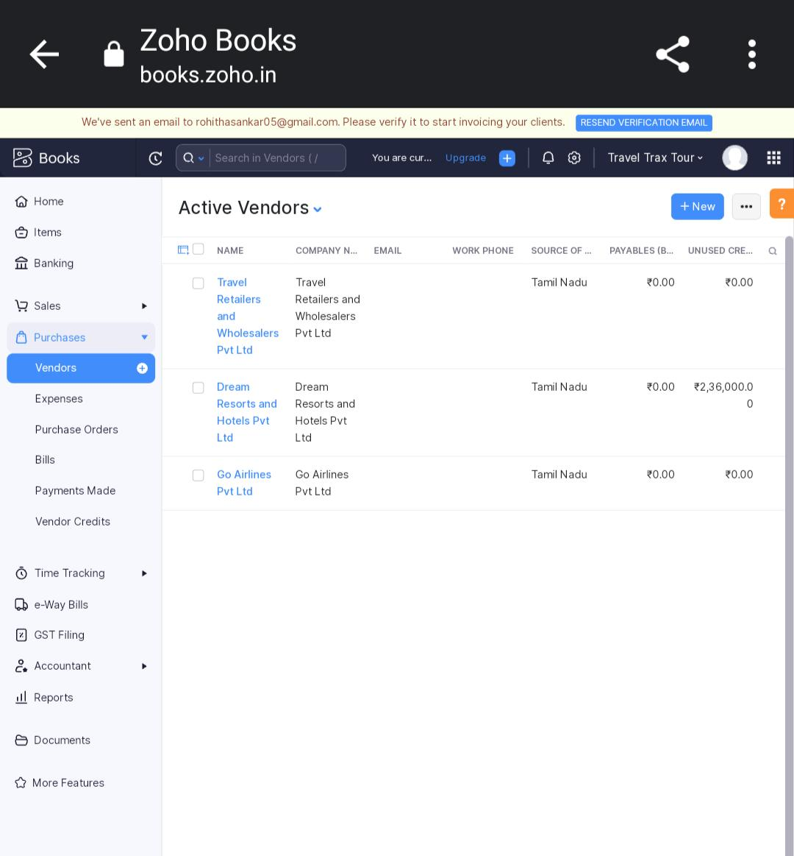

**CUSTOMER:**

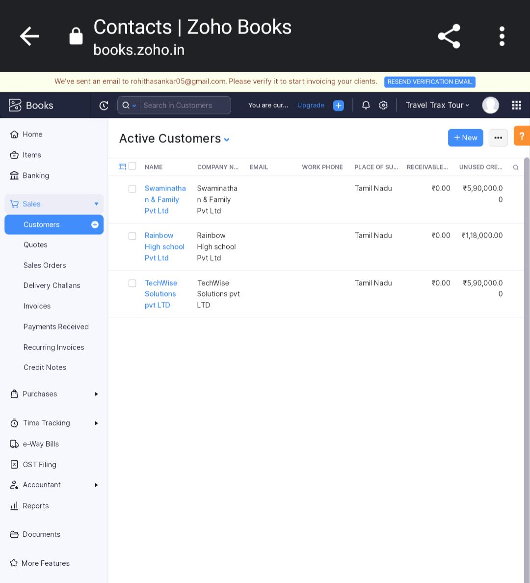

**JOURNAL :**

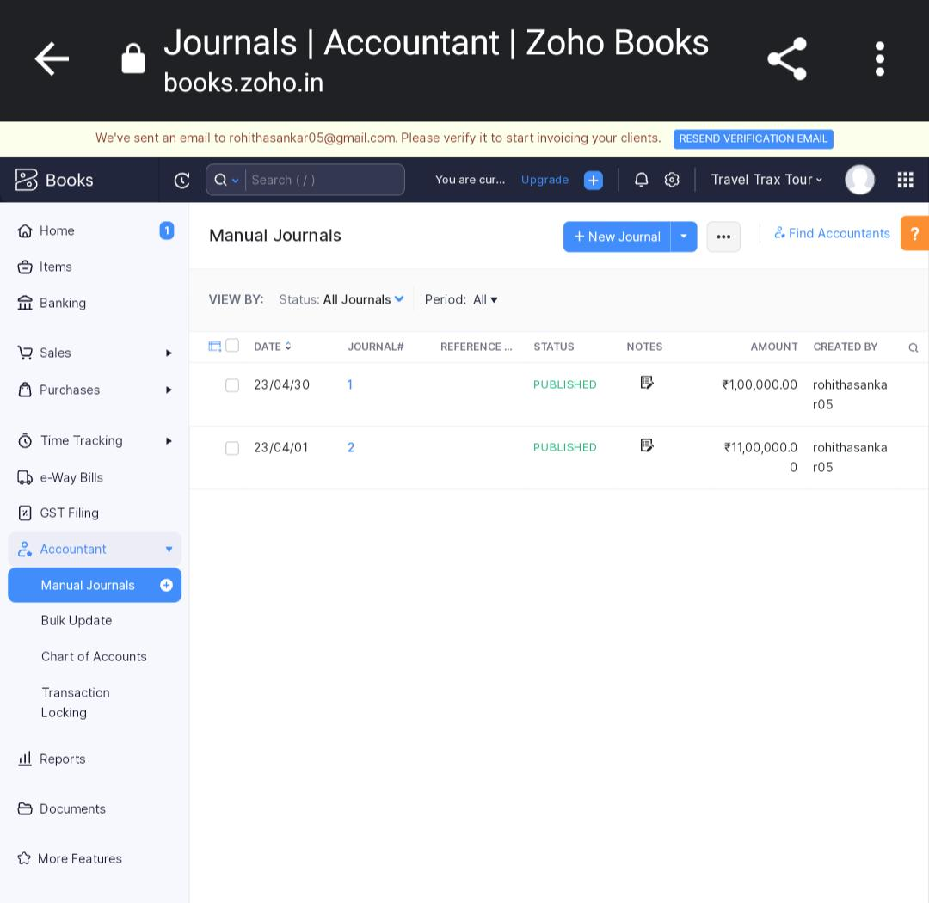

**BANKING:**

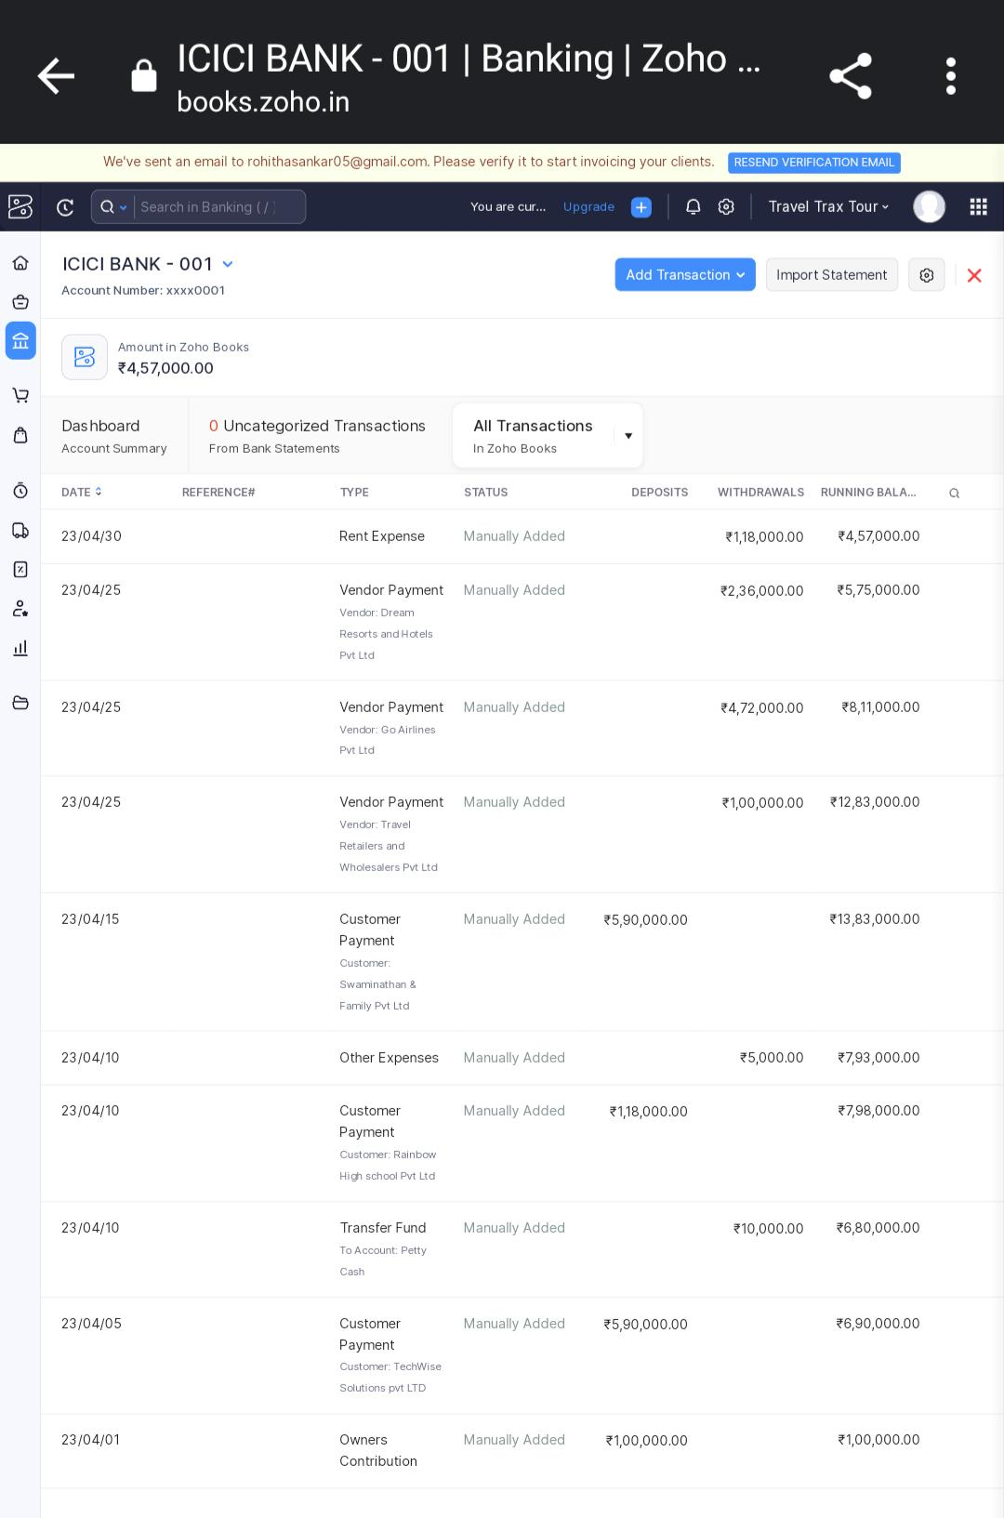

1. **ADVANTAGES OF TRAVEL TOURISM**
2. **Cut Through the Noise**

**When researching your next vacation, the internet can be both wonderful and overwhelming. An experienced travel agent will weed out the mediocrity and focus your attention on top personal recommendations.**

1. **Completely Customized**

**Travel agents have all the tools to seamlessly piece together the exact trip you are looking for, which can be challenging and time consuming to do on your own. They have an ever-expanding list of trusted contacts and suppliers, from private drivers to luxury VIP experiences.**

1. **More Money For Souvenirs**

**Travel agents not only save you time, but they can also save you money. Agencies who belong to larger networks, such as Virtuoso, can land you deals like special pricing on hotels and airfare that you can’t access on your own. They are also sometimes able to offer special bonuses like complimentary room upgrades, spa discounts and more. Most travel professionals will charge a nominal fee for their services and expertise, but it often pays for itself with these extra perks.**

1. **Service from Start to Finish**

**Just like at Trek Travel, travel agents see your trip through from your first consultation until the time you land back home. Agencies will typically offer a 24-hour emergency line in case you run into any unexpected delays or issues while traveling. They can even quickly assist you in the case of widespread delays such as airline strikes or major storms. Long hold times with airlines can mean all the good alternative flights are taken by the time you speak to a representative.**

1. **Feel Like a Celebrity**

**Some travel professionals have connections with top tourist destinations due to their high volume of sales. On occasion, travel agents can organize VIP experiences such as private after-hours tours of normally crowded exhibits, exclusive access to areas closed to the public, or highly-sought after event tickets that sell out quickly.**

**Starting to see the benefits of using a travel agent for your next trip? Now find a great travel agent near you:**

**Travel Leaders**

**Virtuoso**

**Travel & Leisure A-List**

**If you would like to receive more information about our dedicated concierge team at Valerie Wilson Travel, ask your Trek Travel trip consultant or contact us today**

**DISADVANTAGE OF TRAVEL TOURISM**

**Challenges Facing Travel Agencies 2022 and Beyond Inflation**

Unstable Labor Market. …

Oil Pricing. …

Post COVID Pandemic Travel Apathy. …

Social Media Deterioration. …

Dynamic Pricing. …

World Events. …

Managing Clients and Global COVID Restrictions and Protocols. …

Developing a Profitable Niche.

Risks for a travel agency business and how to solve them

Travel agency problems.

Your reputation and duty of care.

Cashflow is crucial to your survival.

Build-in financial resilience.

The primary reason travel merchants are classified as high risk is chargebacks. Chargebacks occur when a traveler calls their issuing bank to dispute a transaction. The travel industry loses an estimated $25 billion in fraud and chargebacks each year.

**5.APPLICATIONS :**

TravelPerk. 4.8. (397) All-in-one business travel booking & management platform. …

Egencia Suite. 3.9. (50) Travel Management Solution. …

Lemax. 4.3. (14) A complete web-based software solution for Tour Operators. …

TravelWorks. 4.5. (12) …

WeTravel. Highly viewed. 4.8. …

Zaui. 4.4. (52) …

Resfinity. 4.5. (6) …

Rezdy. 4.6. (226)

Travel agency solution

Lemax helps book flight tickets or products from third party suppliers, manage customers profiles, fully automate sales processes, automate marketing efforts, manage accounts and gain full insight into the travel business.

Easily add travel products

Add travel products such as accommodation, packages, entrance tickets, excursions and other activities, transfers, rent-a-car, vessels, cruises and much more.

Book directly from third party suppliers

Get the best prices from multiple third-party suppliers such as HotelBeds. Increase productivity by viewing all the products of all suppliers on a single Lemax product search screen.

1. **CONCLUSION**
   1. **PROFIT AND LOSS :**

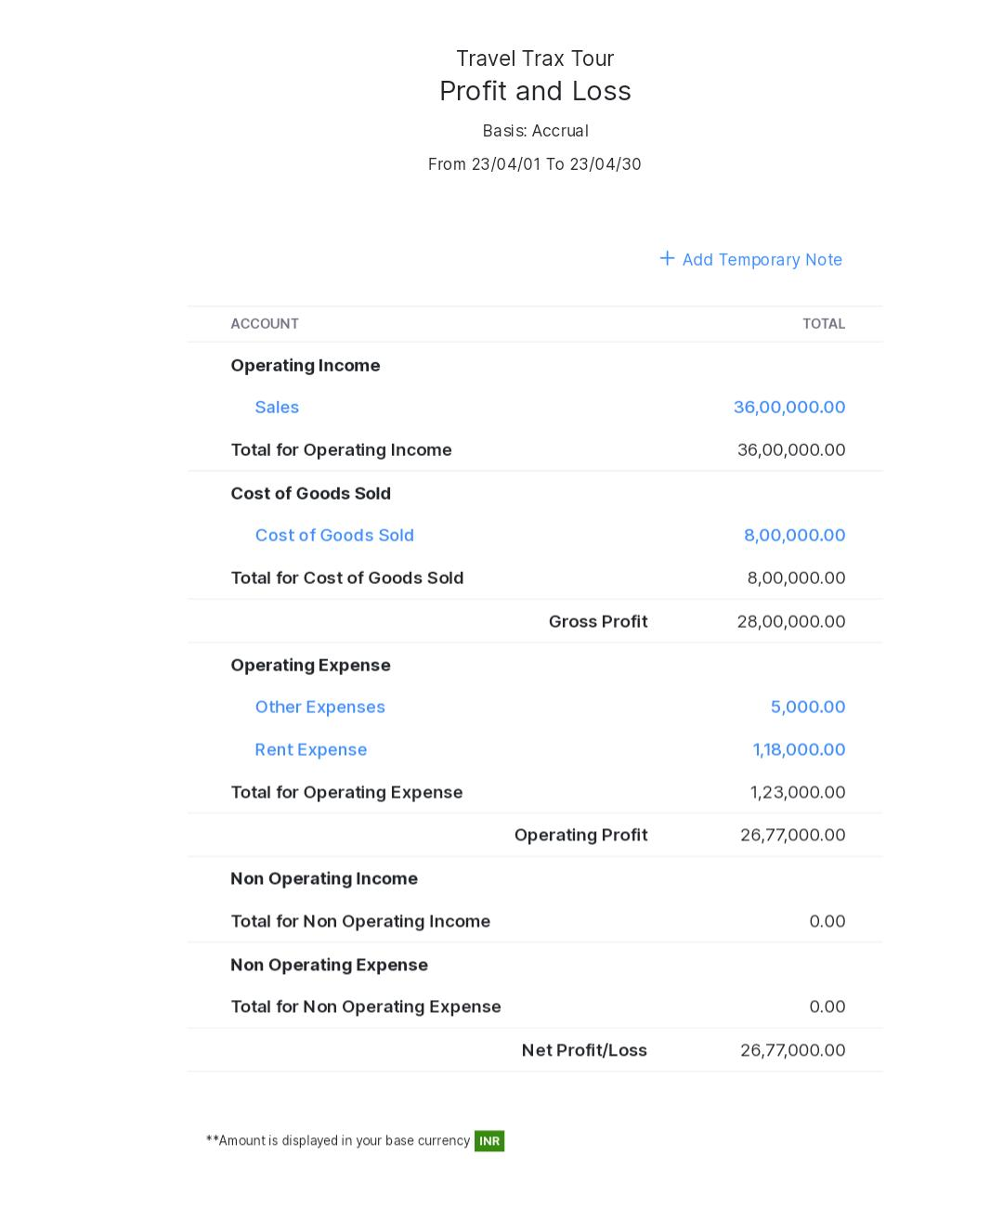

**2.BALANCE SHEET :**

